EVALUATION LAB 3
1. Write a matlab program to segment the following image using global thresholding (5)
2. Write a matlab program to segment the following image using global thresholding and otsu’s thresholding algorithm. (10)
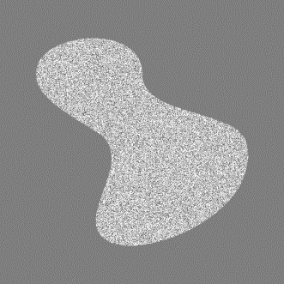

3. Write a matlab code to segment the following image using global thresholding , otsu’s thresholding algorithm and region split and merging.(5)
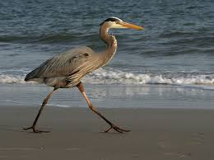
4. MORPHOLOGICAL OPERATION TO ENHANCE THE QUALITY OF THE IMAGE GIVEN BELOW. (5)
